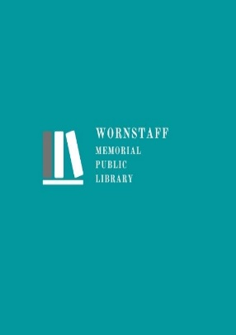

740.747.2085

www.wornstafflibrary.com

302 E. High Street

Ashley, Ohio 43003

Website Accessibility Statement

The Wornstaff Memorial Public Library is committed to providing all patrons unimpeded access to our resources, programs, and services. We are actively working to increase our website accessibility and usability.

In pursuit of greater accessibility, Wornstaff Memorial Public Library aspires to AA conformance with W3C’s Web Content Accessibility Guidelines (WCAG) 2.1. These guidelines are an industry standard which help web resources be more accessible to all people, regardless of technology or ability.

The library understands that even if we surpass these guidelines there may yet be inadequate accessibility for some patrons. Therefore, we are always seeking to implement new solutions to ensure all people can access our resources, programs, and services. If you encounter any accessibility issues when using our website, please contact us by email at information@wornstafflibrary.com or by phone at 740.747.2085.